Website analysis:

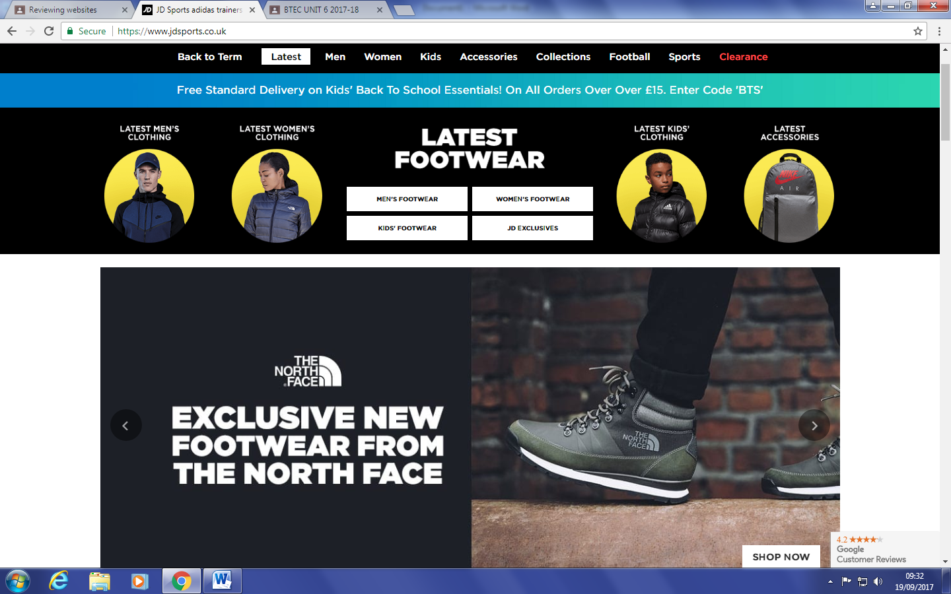JD sports (<https://www.jdsports.co.uk/>)

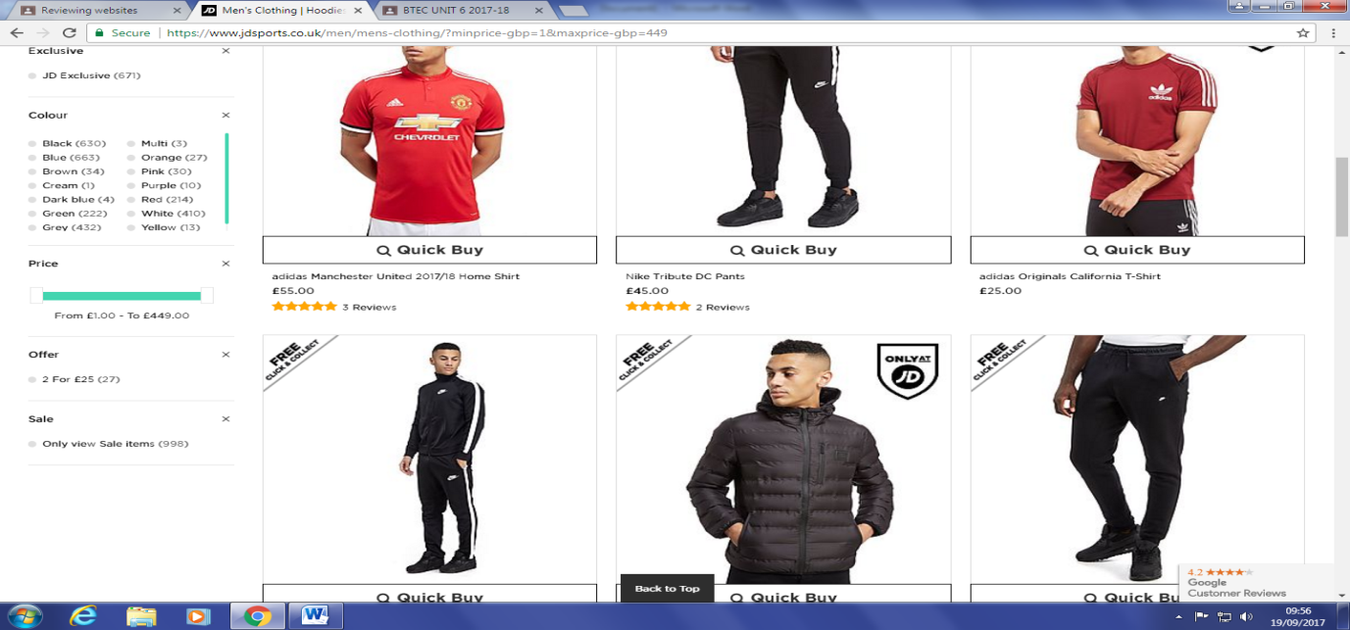JD sports are targeting a specific audience in its website design and advertisement. Various pictures displayed on the website show a specific age range of young children to mid adult such as 7-25. This is also noted in the navigation bar as it displays its categories as ‘Men’, ‘Women’ and ‘Kids’. JD sports are a shopping website that sells items of clothing of all types. I believe that most of the audience need an income as some items of clothing can be very expensive for example; the image below shows that for all men’s clothing the price range is between £1.00-£449.00 however, some may be dependent on the family for money such as young children and teenagers. JD also targets a range of cultures as well as ages which are displayed in its home page images and throughout the website, it is clear it is a multicultural audience as well as both genders.

Secondly, the information is communicated effectively as it is easy to navigate through different products with a ‘quick buy’ option which allows an option to quickly purchase a Item if they already know what they want to buy prior to going onto the website.

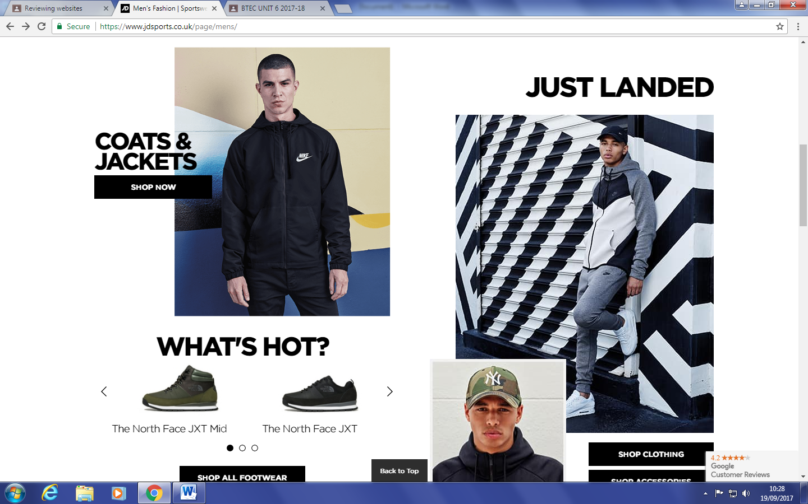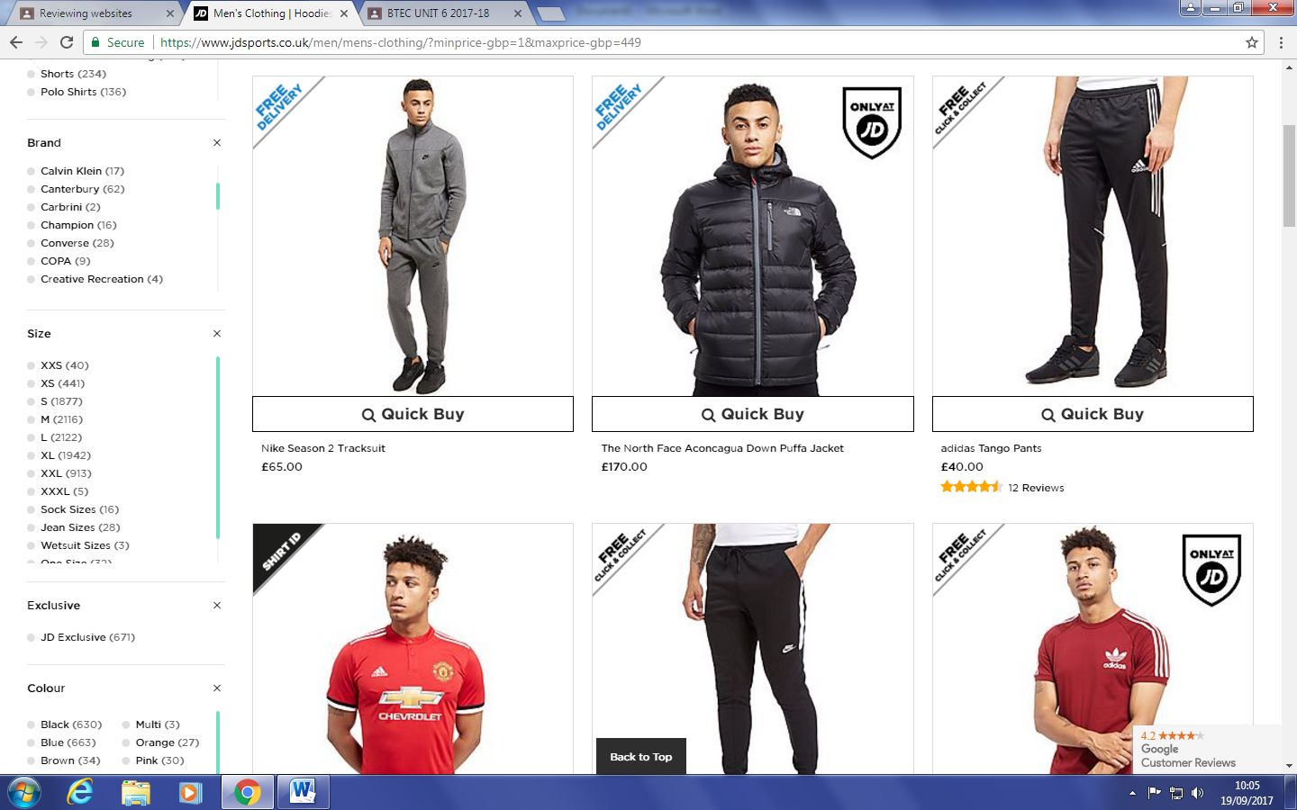The information on the individual clothing page is clearly communicated as there are images of the items for sale being worn so a customer can clearly see what the item is as well as rotating the image to see different angles. Also the navigation bar on the left is very detailed as there are many different filters and options to find the best product for you. This makes it very easy to find your preferred item depending on your size, brand, colour etc. Underneath each product the price, name and rating is displayed so you don’t actually have to waste time and click on the product to see this information. On each individual page the JD logo is displayed, they also have the same colour scheme continuously of black and white as well as contact details on every page at the bottom. This continuation of the same page layouts and colours gives JD a professional feel and look.

The content for JD is extensive with many pictures on each web page with many different prices, numbers, and images for each product with data such as filters for prices that can be altered and interpreted for the customer. On the home screen there is a slide share that automatically changes that shows different products.

Super dry (https://www.superdry.com/)

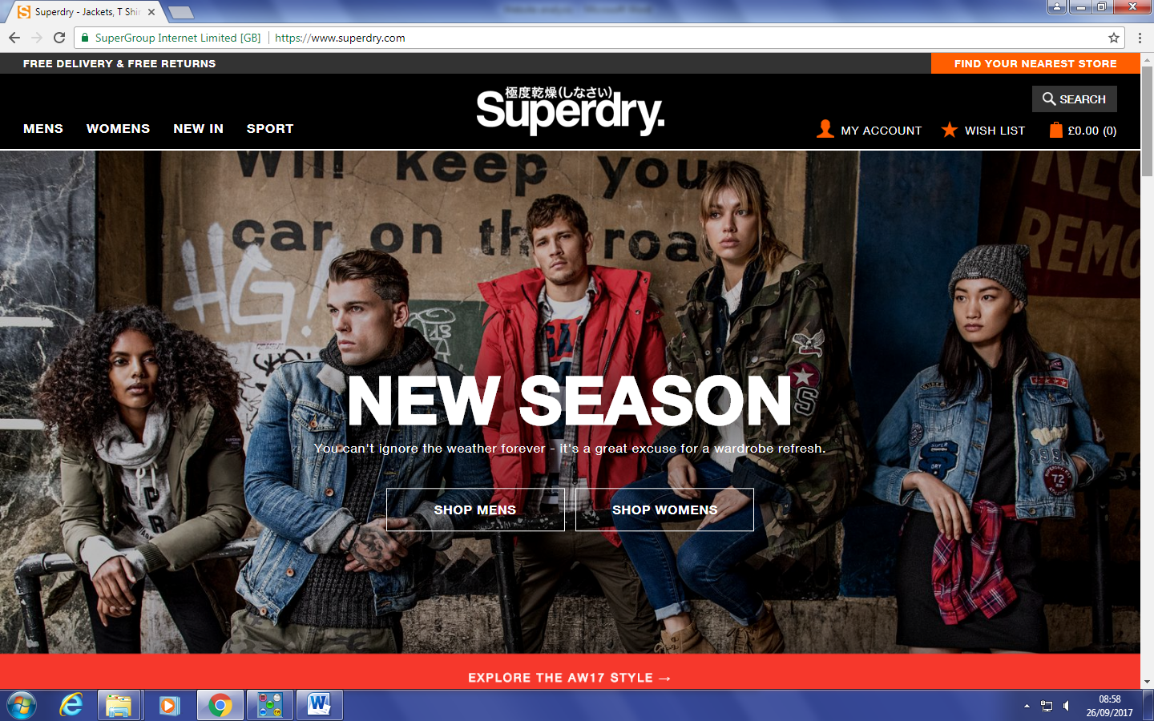

By looking at the first homepage of superdry, I can see the target audience is predominately young men and women this shown by the picture above of the clothing models who are young adult to adults, and the purpose of this website is to sell all types of clothing to these young men/women. I believe superdry is targeting individuals with an income as some of the items sold can become very expensive some even reach £400+. Therefore, superdry is targeting an audience with a disposable income with high quality products. It is also important where the customer lives as superdry only offer free delivery to the UK, USA, Canada and various other countries consequently if you live in a low economically developed country you may have to pay to deliver or be unable to purchase items all together.

The structure of the website is good as navigation is very easy for any customer, the search bar and basket on the right, with the different product ranges and options on the left, and finally the logo in the top centre of the screen acting as a home page link, although to the naked eye it would not appear as a home page button to some customers.

Some of the company’s integral design is important and can be seen throughout the page such as the logo on nearly every different page; it is also in the same spot on every page adding to an already simplistic design. The cooperate colour scheme of orange, black and white is kept throughout the page, this makes the company’s look very professional and sellable, because the customers feel they are purchasing high quality items as the website itself is high quality too.

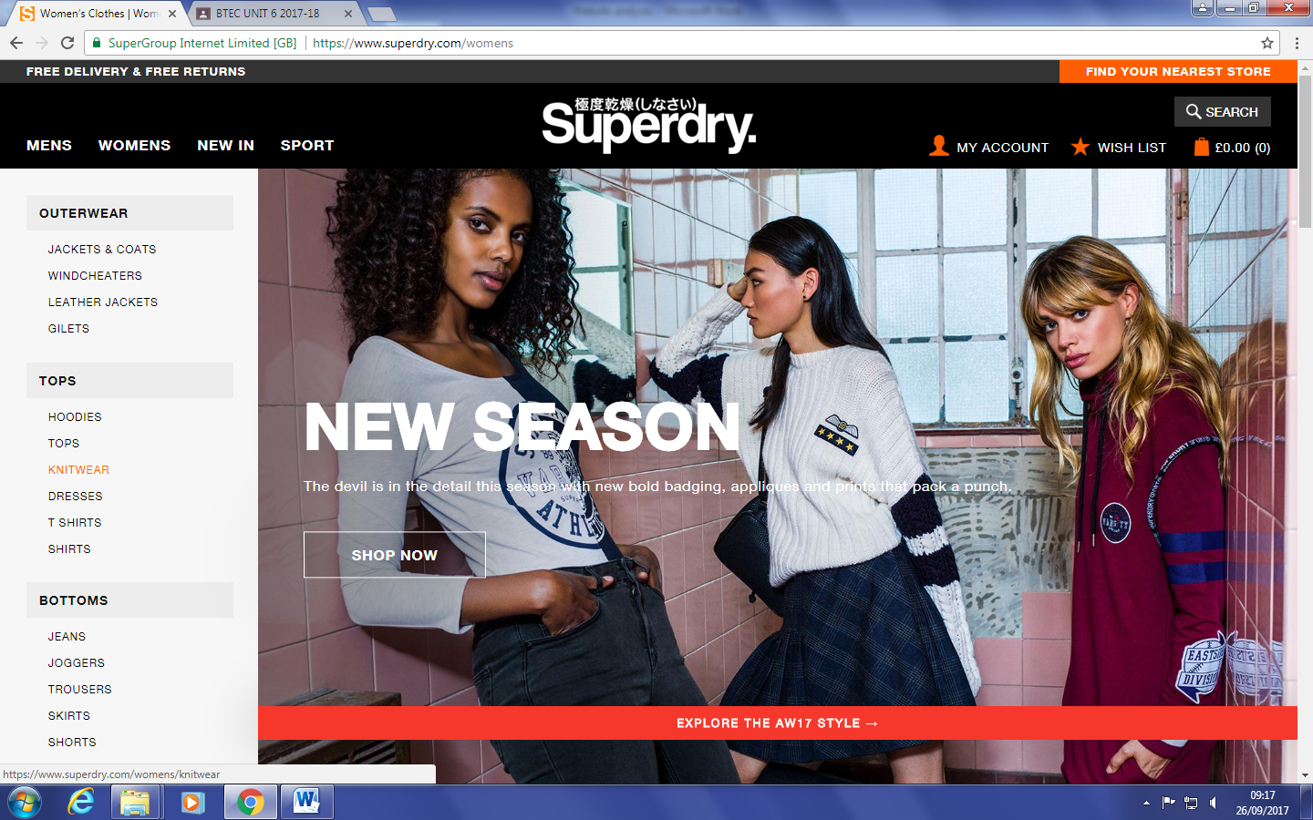

On the superdry website there are plenty of high quality images, lots of links to different pages across the website and lots of data such as prices, different products, colours for products are all included.

North Face: https://www.thenorthface.co.uk/

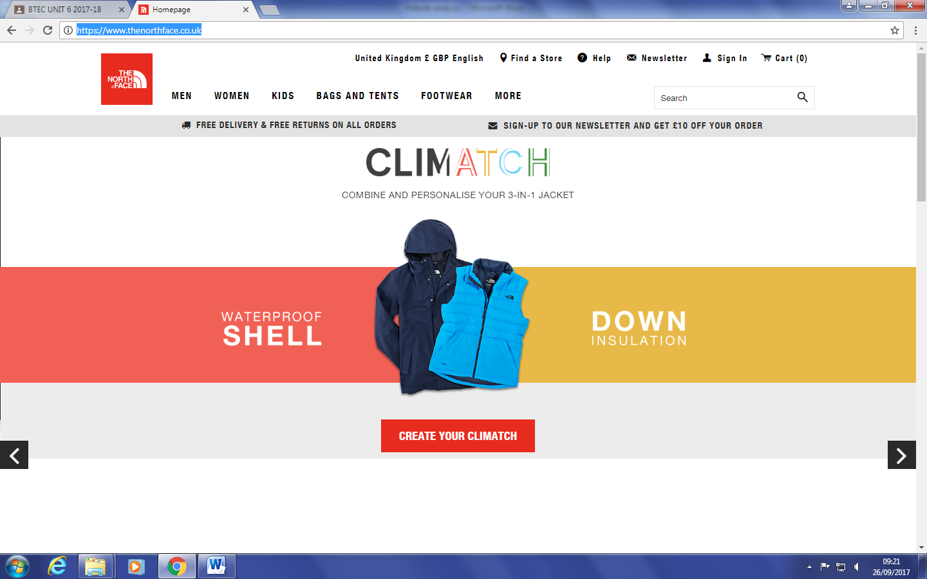

The North Face website is not targeted at a specific audience and this is solidified by the fact that the images are of a range of different people giving the impression that the target audience is everyone from kids to older men and women. North Face sells a range of items to its audience from heavy winter clothing for the harshest conditions to summer wear and sports outfits. This allows a wide range of customers to use its services and this is seen by the many different search options in its menus. I believe the customer does need an income as this is a selling website and real money is needed to purchase items from it, however the young teenager or child needs it parents or carers to have an income if they want to purchase something from the website. It does also matter where you are from as the delivery policy is limited to certain economically established countries e.g. USA, UK, Canada and more. The information Is effectively communicated as each different aspect of the website is located with a link and a image to show the user what it is searching on for example jackets, footwear and tops in the image below.

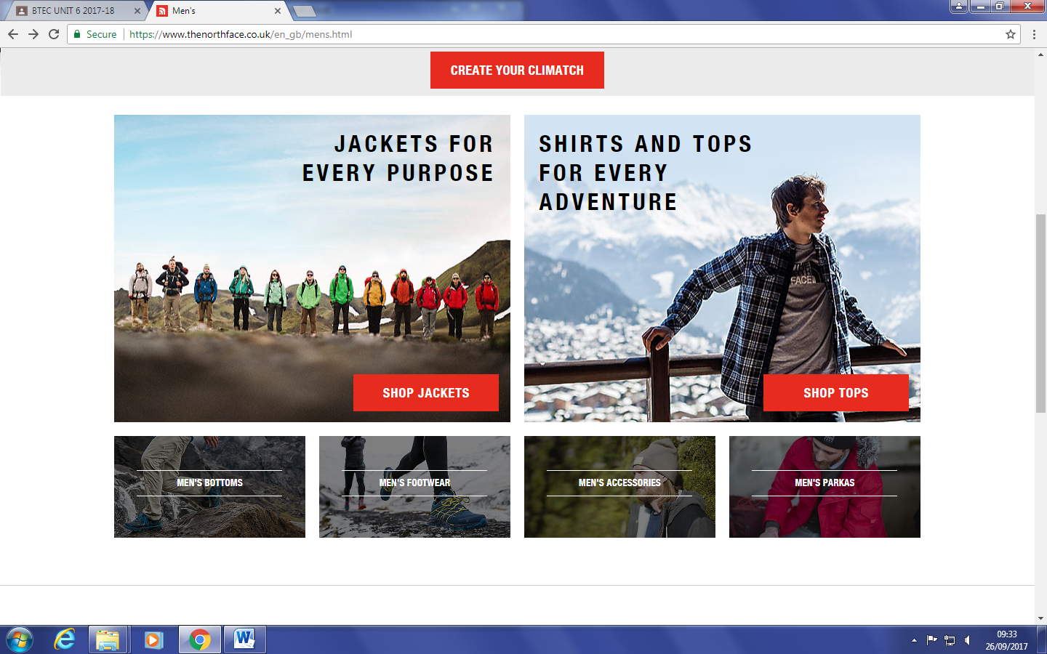

The cooperate colours of orange is shown throughout the website but it is not the primary colour and stand out the most which can be a good thing because alternate colours like black and white add a simple design and does not strain the user eyes like a bright orange would otherwise, also the North Face logo square is located in the top left of every slide, and acts as a link to the home page. The content is mainly images, and links all across the page make it easy to travel and navigate between web pages.